Running MapReduce WordCount Program in Python
Grishma lamsal
2431171

Before running the below commands make sure that you have :

- Switched to the hadoop user.
- Navigated to the hadoop Sbin directory.
- Started the Hadoop Distributed File System (HDFS).
- Started the YARN Resource Manager.

If not refer to the below image to complete the above tasks :

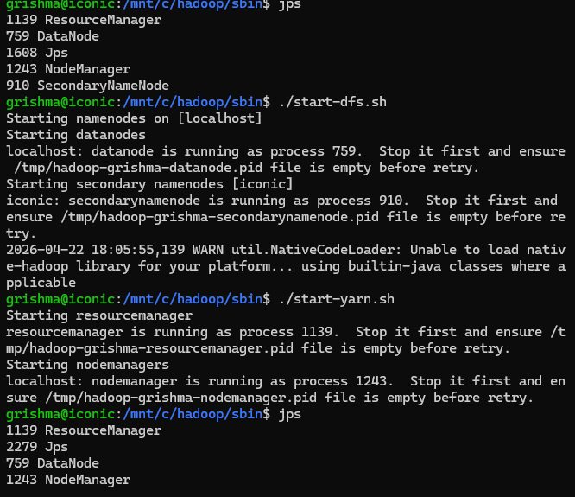

If jps (Java Processing Status) lists all the above running java processes, then you are good to continue with the below commands.

- Python comes pre-installed in newer versions of Ubuntu. However, if you want to check which version is installed on your machine:

For python version check :

~$ python3 --version

- If the python is not installed then you can install the python with the following code:

~$ sudo apt install python3

- Create input_word folder and insert a text file in the HDFS.

~$ hdfs dfs -mkdir /input_word

~$ hdfs dfs -put hadoop-3.2.4/LICENSE.txt /input_word/
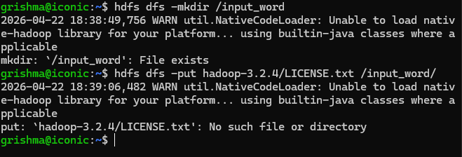
- Verify the creation of the directory and the file.

~$ hdfs dfs -ls /

~$ hdfs dfs -ls /input_word/

~$
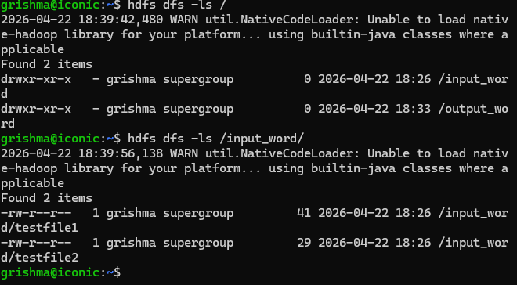
- Now we have to create a mapper and reducer. To create a mapper class first we have to create an empty file and add the code related.

- Type “touch mapper.py” and press enter. Similarly for reducer “touch reducer.py” and press enter. You will have two files located in your /home/hdoop directory.

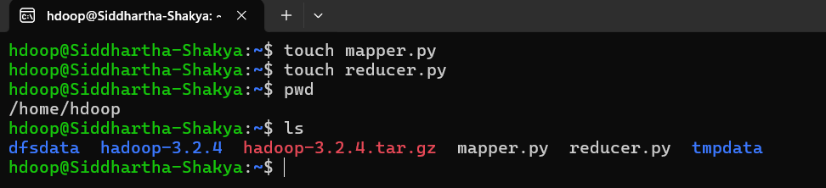
- Open the mapper.py typing “nano mapper.py” and add the following code.

~$ nano mapper.py

Copy paste the below code :

#!/usr/bin/env python3
"""mapper.py"""

import sys

# input comes from STDIN (standard input)
for line in sys.stdin:
# remove leading and trailing whitespace
line = line.strip()
# split the line into words
words = line.split()
# increase counters
for word in words:
# write the results to STDOUT (standard output);
# what we output here will be the input for the
# Reduce step, i.e. the input for reducer.py
#
# tab-delimited; the trivial word count is 1
print("%s\t%s" % (word, 1))

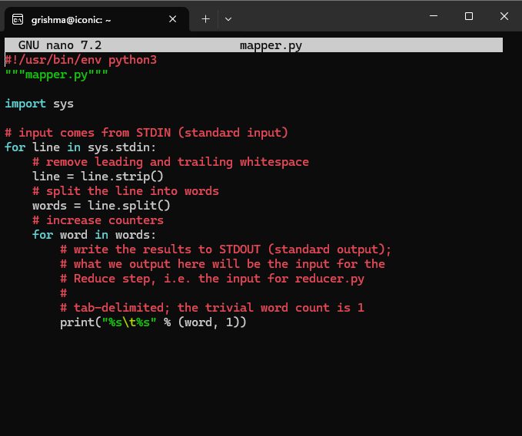

- Now open the reducer file by typing “reducer.py” and press enter. add the following code in reducer.py.

~$ nano reducer.py
Copy paste the below code :

#!/usr/bin/env python3
"""reducer.py"""
from operator import itemgetter
import sys

current_word = None
current_count = 0
word = None

# input comes from STDIN
for line in sys.stdin:
# remove leading and trailing whitespace
line = line.strip()
# parse the input we got from mapper.py
word, count = line.split("\t", 1)
# convert count (currently a string) to int
try:
count = int(count)
except ValueError:
# count was not a number, so silently
# ignore/discard this line
continue

# this IF-switch only works because Hadoop sorts map output
# by key (here: word) before it is passed to the reducer
if current_word == word:
current_count += count
else:
if current_word is not None:
# write result to STDOUT
print("%s\t%s" % (current_word, current_count))
current_count = count
current_word = word

# do not forget to output the last word if needed!
if current_word == word:
print("%s\t%s" % (current_word, current_count))
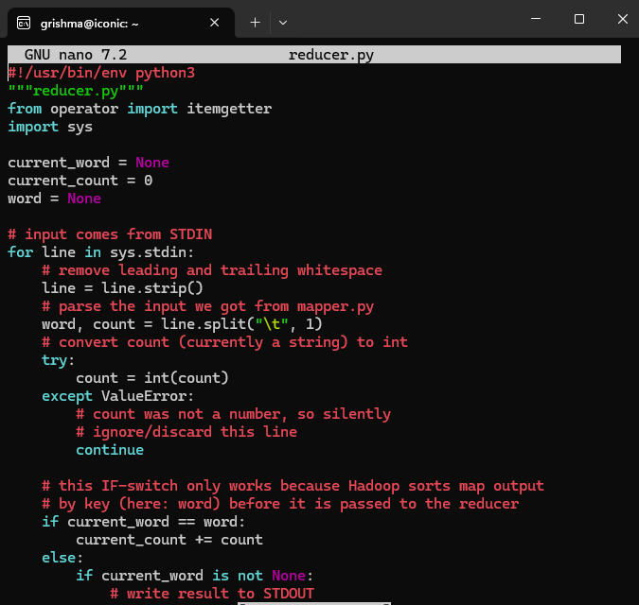
- Now we have to give permission for the mapper and reducer. Type the following commands.

~$ chmod +x /home/hdoop/mapper.py

~$ chmod +x /home/hdoop/reducer.py

Testing the mapper.py and reducer.py

- To test the mapper type the following code and enter.

~$ echo "foo foo quux labs foo bar quux" | /home/hdoop/mapper.py

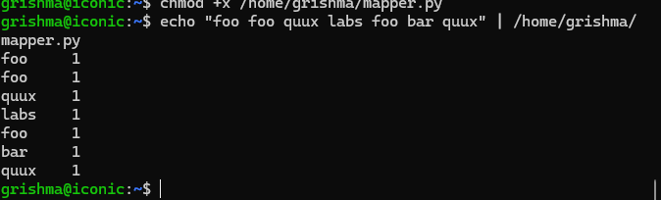
- Now test the mapper and reducer code together

~$ echo "foo foo quux labs foo bar quux" | /home/hdoop/mapper.py | sort -k1,1 | /home/hdoop/reducer.py

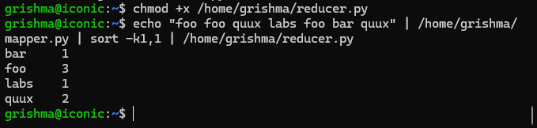

Running the Mapper.py and reducer.py in HDFS

- Now to execute the code run the following code.

~$ hadoop jar /home/hdoop/hadoop-3.2.4/share/hadoop/tools/lib/hadoop-streaming-3.2.4.jar \
-mapper /home/hdoop/mapper.py \
-reducer /home/hdoop/reducer.py \
-input /input_word/LICENSE.txt \
-output /output_word
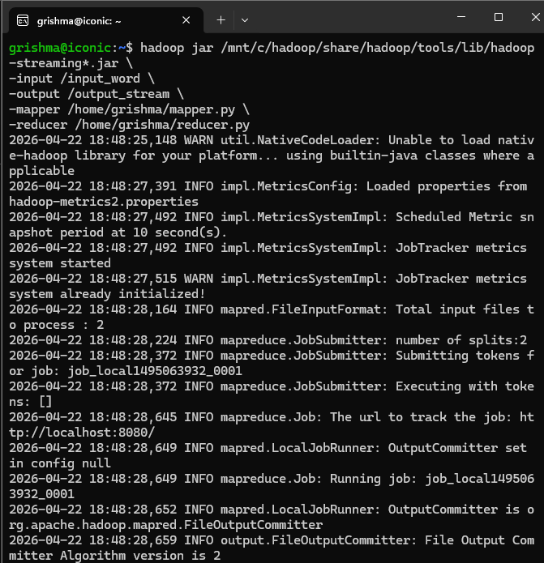
- if you have output folder then you have to delete that

Note: It is just the syntax. Please enter proper credentials as your system has been configured.

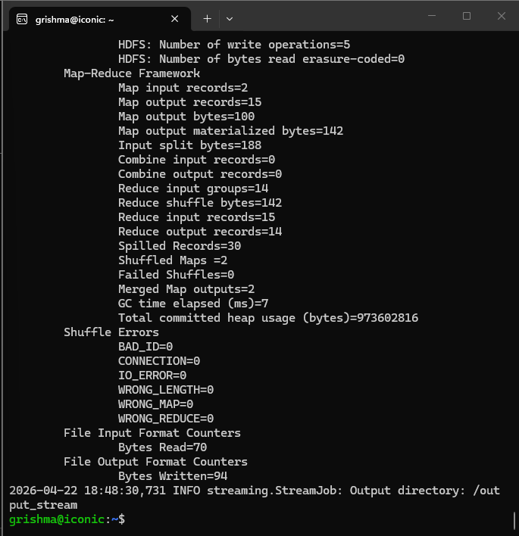

- Now you will see the output folder and the output file. output_word in my case as I have given that specific name while executing map reduce code.

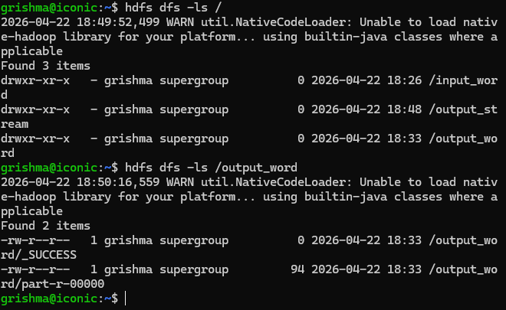
- Now you can test if the map reduce program in the python worked correctly or not by executing the following command.

~$ hdfs dfs -cat /output_word/part-00000
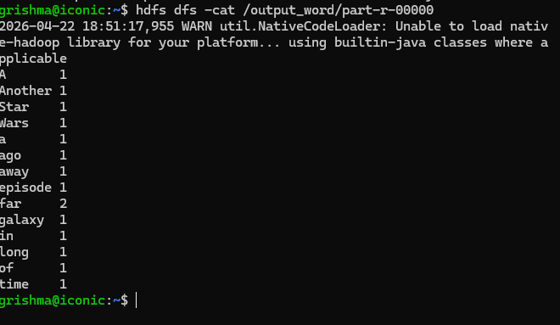
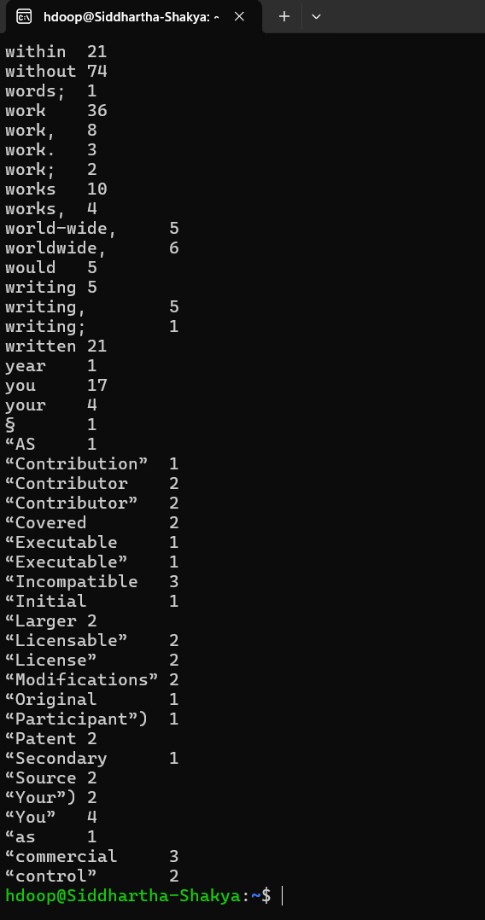

!! WELL DONE !!

- References

- Writing An Hadoop MapReduce Program In Python

